**CSA1195 OBJECT ORIENTED ANALYSIS AND DESIGN**

**DAY 3 LAB PRACTICAL : 10.08.2023**

**NAME : P.GUNADEESH REDDY**

**REGISTER NUMBER : 192111198**

1.Develop a system using UML for Recruitment System, to recruit the applicant for a particular job in the company. It was controlled by the central management system to manage the details of the particular applicant who has to be recruited by a Company.

USE CASE:

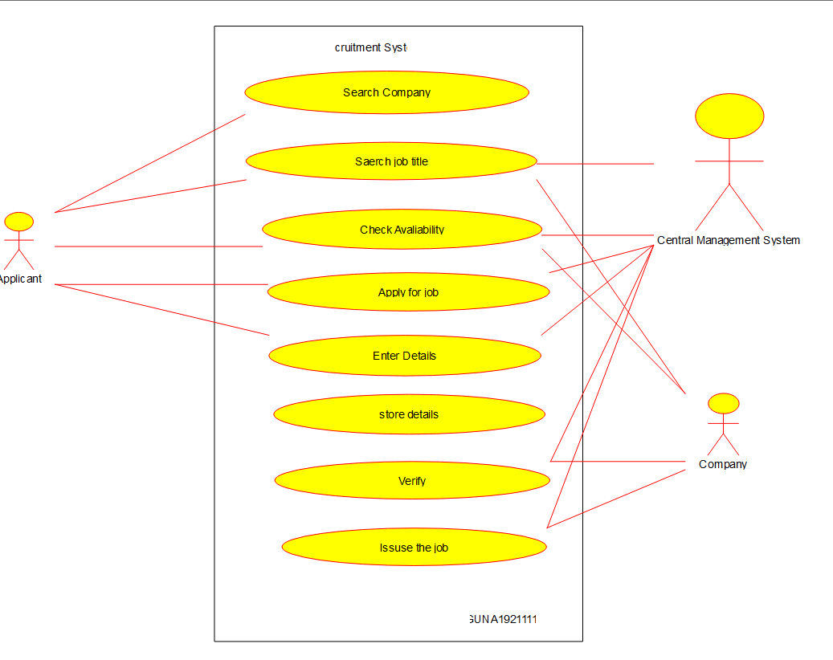

CLASS:

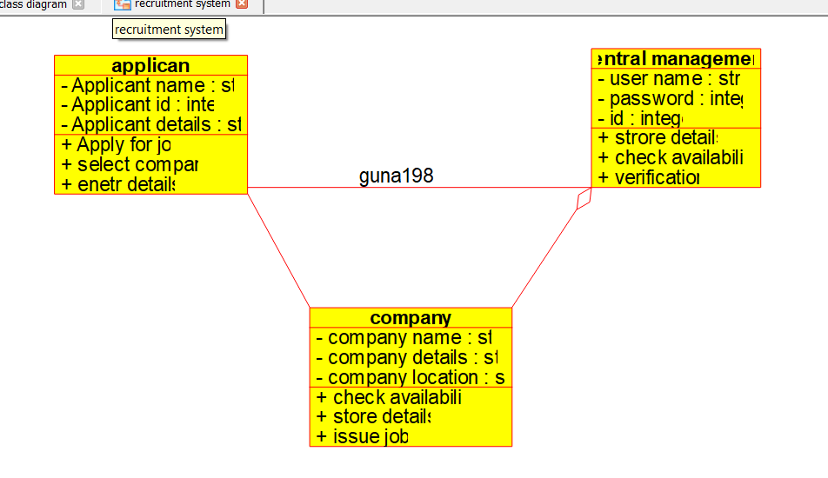

ACTIVITY:

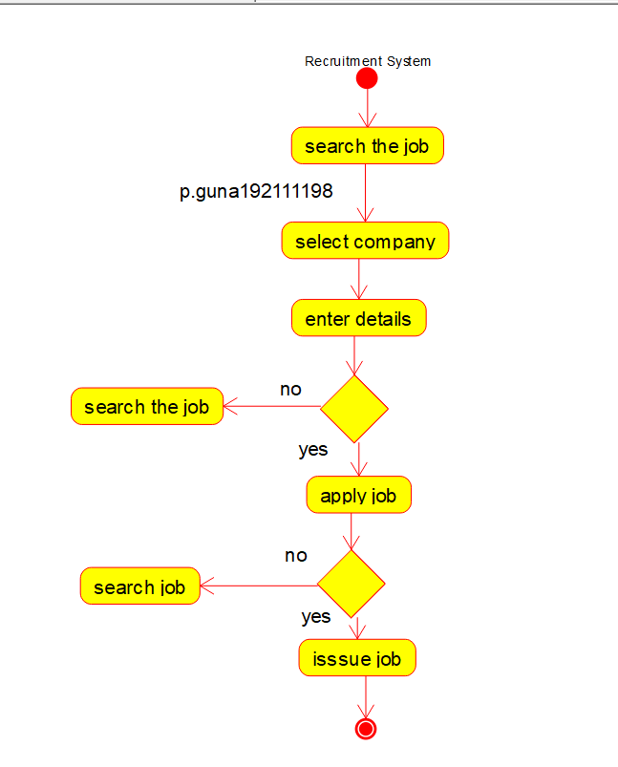

SEQUENCE:

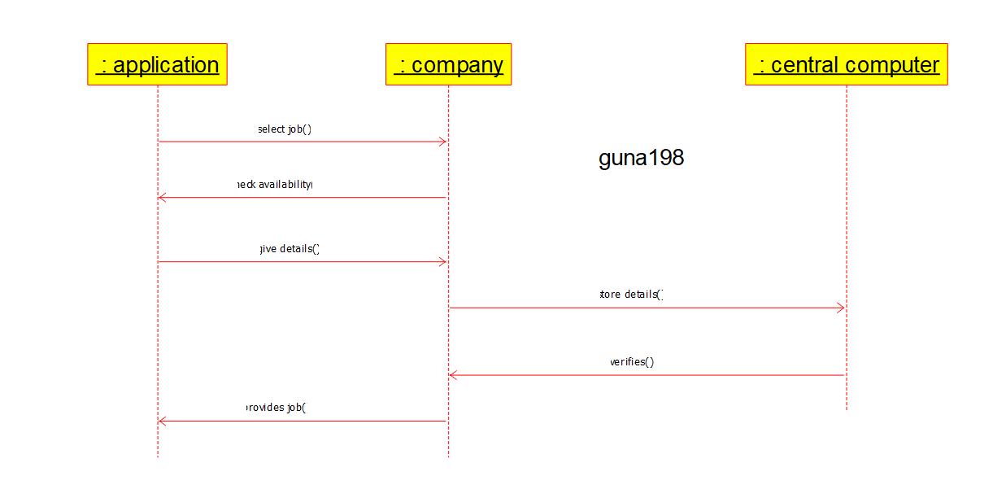

COMPONENT:

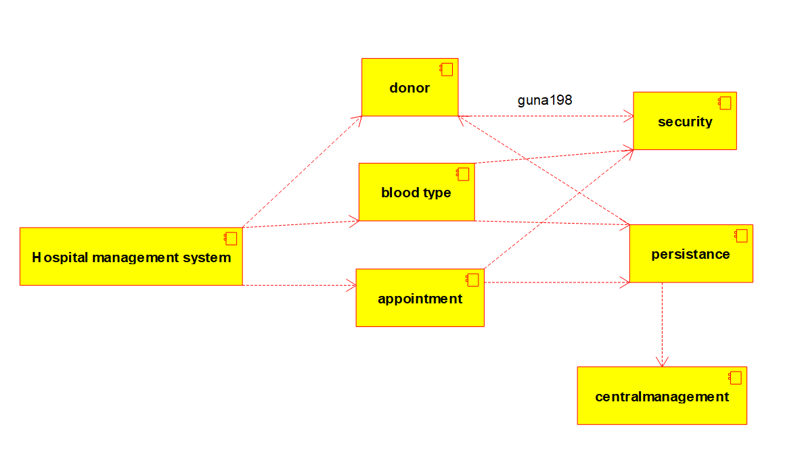

COLLABARATION:

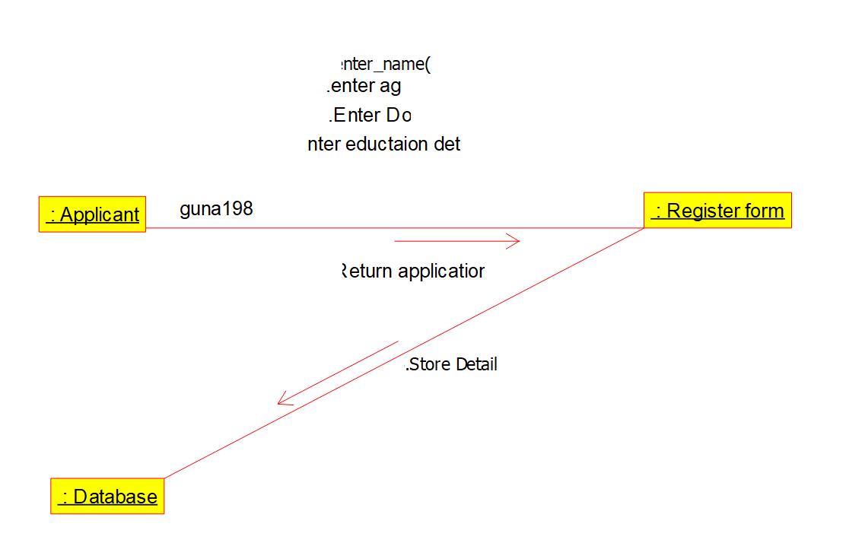

DEPLOYMENT:

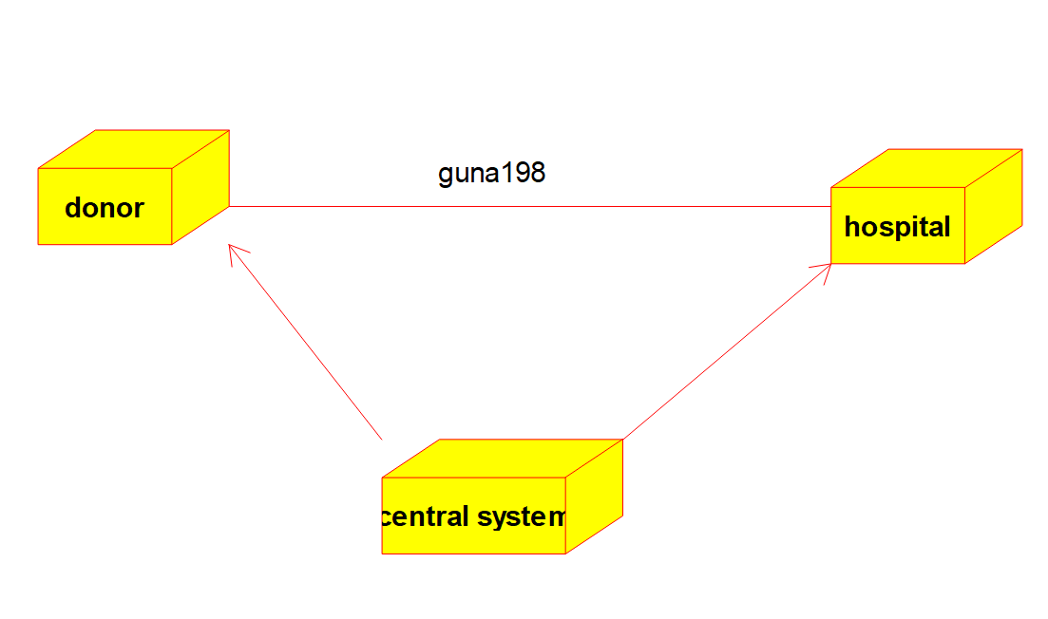

STATE:

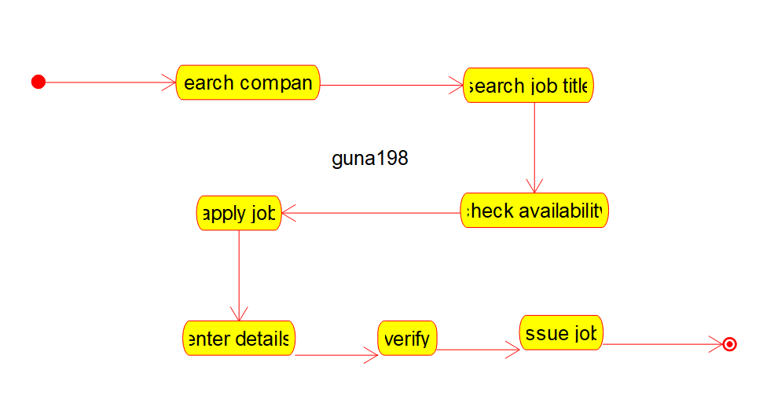

ERDIAGRAM:

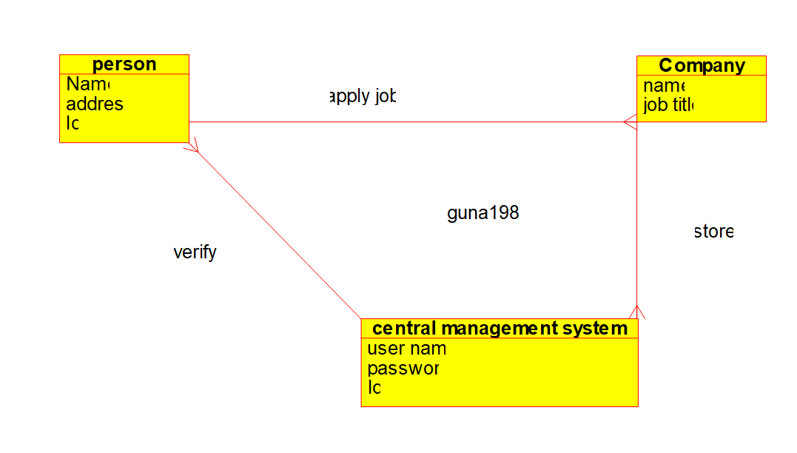

2. Develop a system using UML for Blood Bank Registration System. The system should have the list of donors and the hospitals can check for the donor's availability and get their appointment. The donor and the hospital can interact with the \central system.

USE CASE:

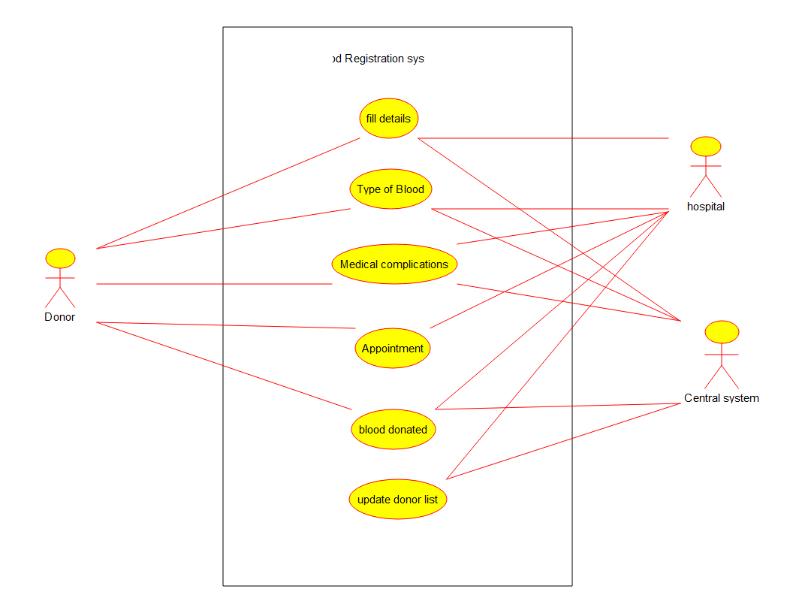

CLASS:

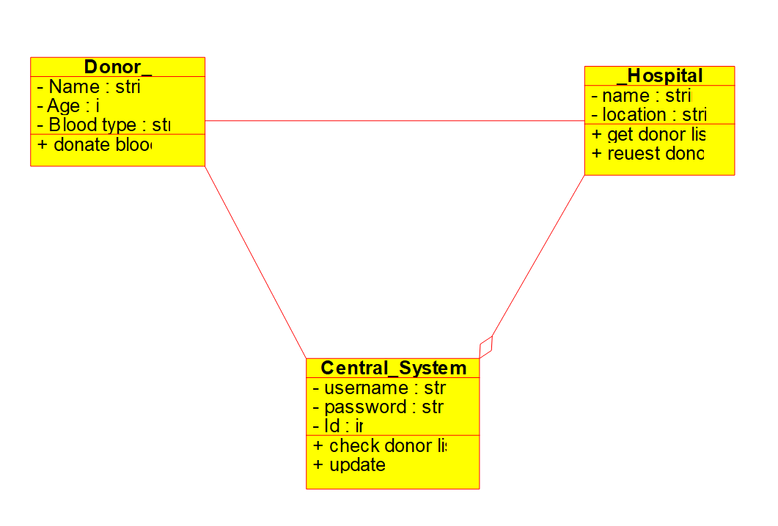

ACTIVITY:

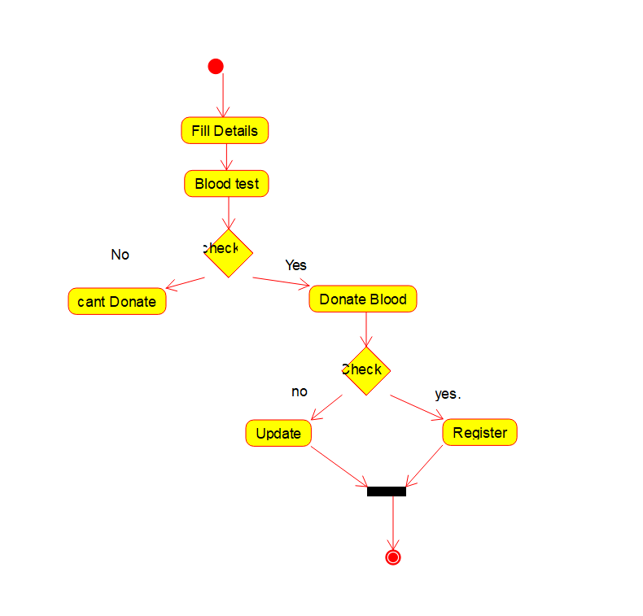

SEQUENCE:

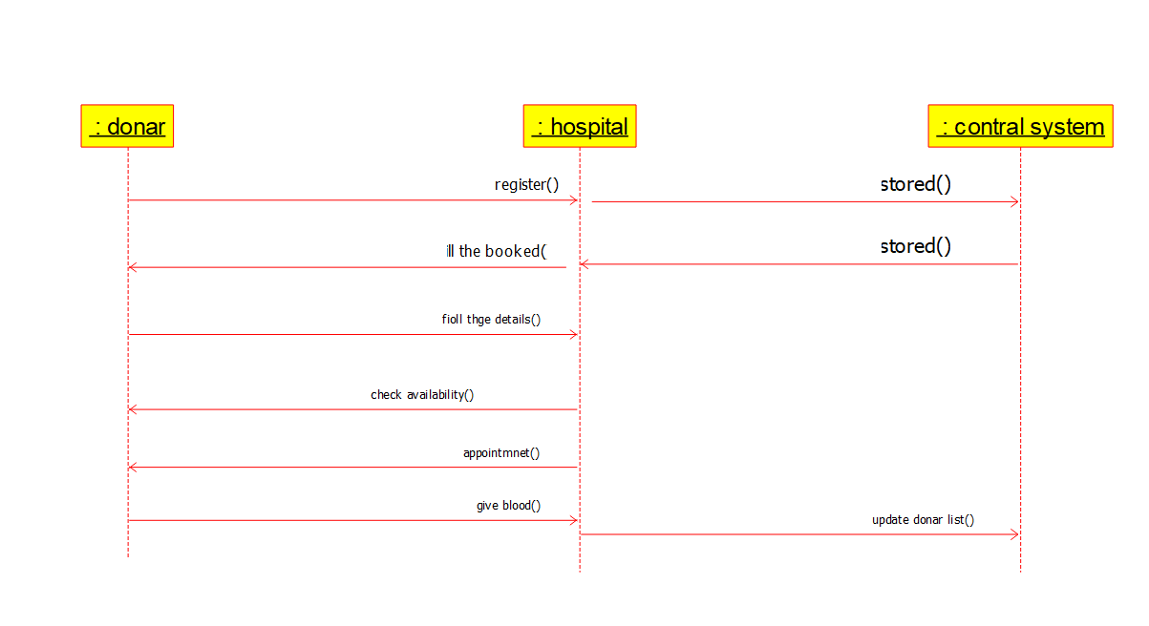

COLLABARATION:

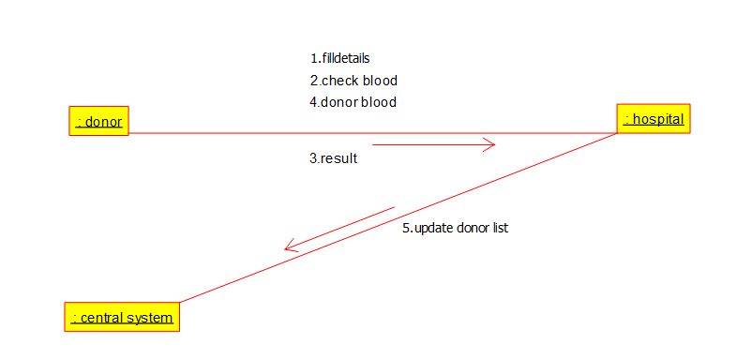

COMPONENT:

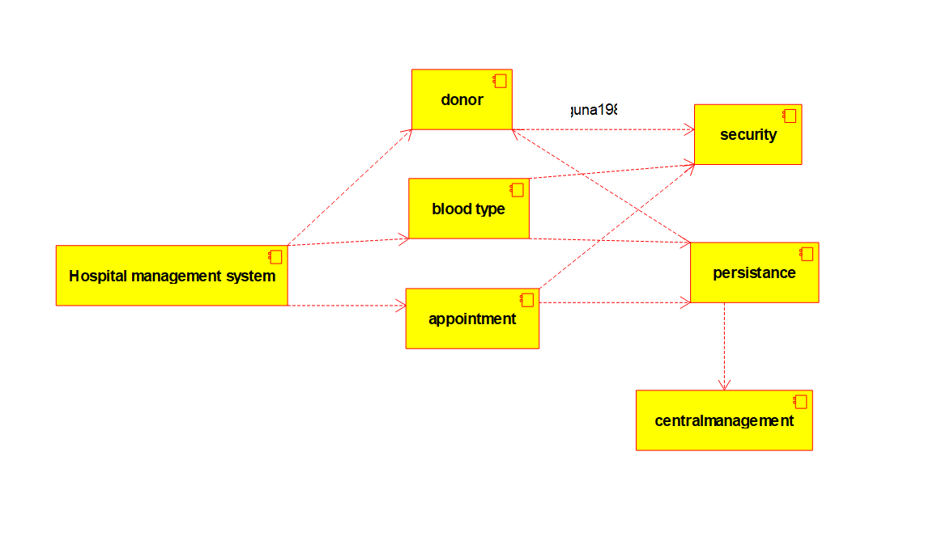

DEPLOYMENT:

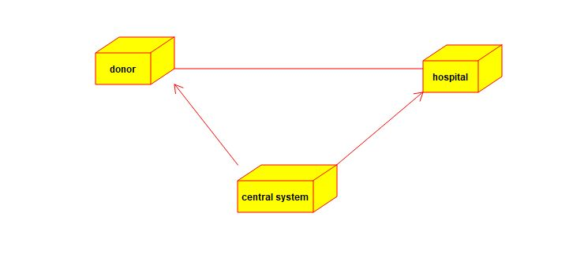

STATE:

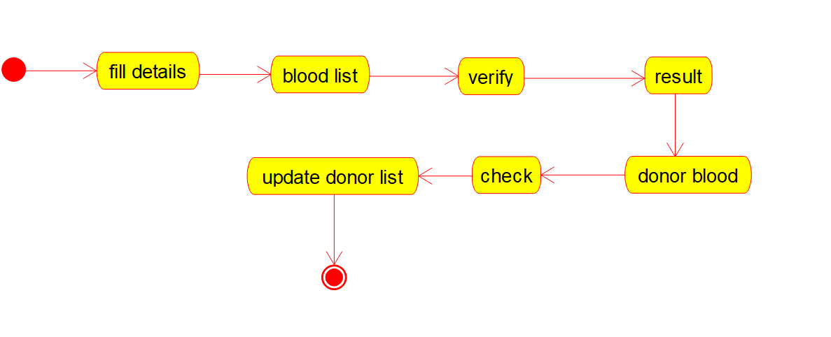

ER DIAGRAM:

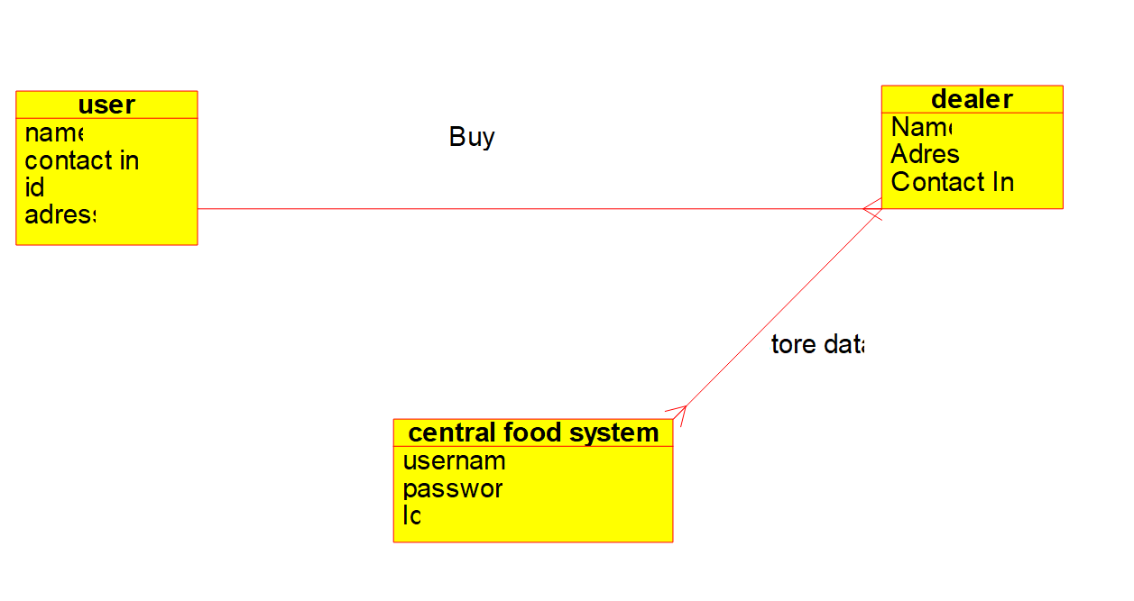

3. Develop a system using UML for Food Order System. In this system, the customer can place orders and purchase items with the aid of the dealer and central food system. These orders are verified, and the items are delivered to the customer.

USE CASE:



CLASS:

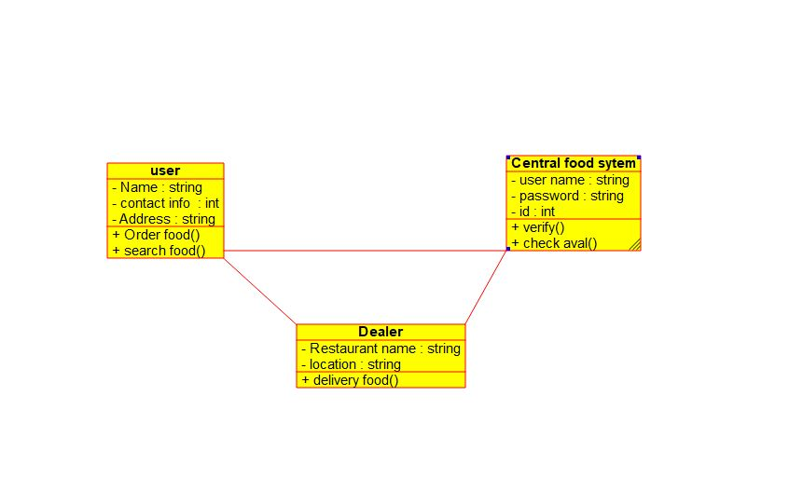

ACTIVITY:

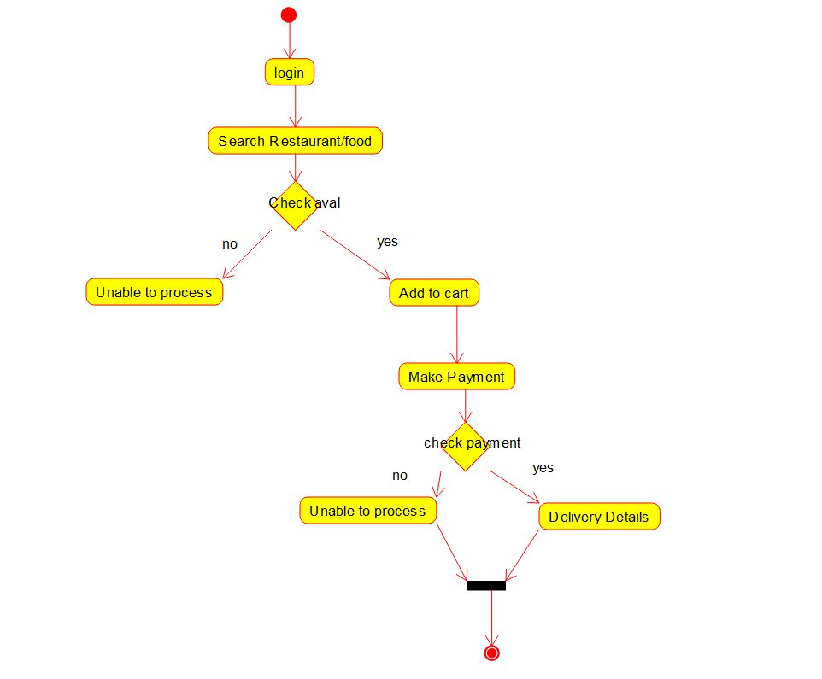

SEQUENCE:

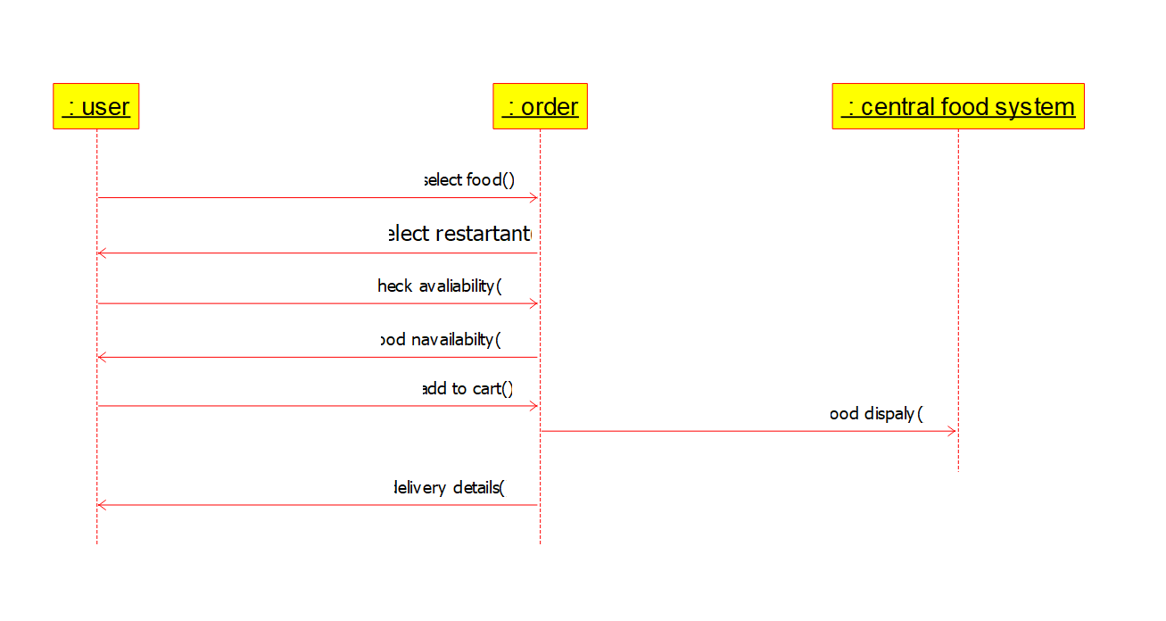

COLLABARATION:

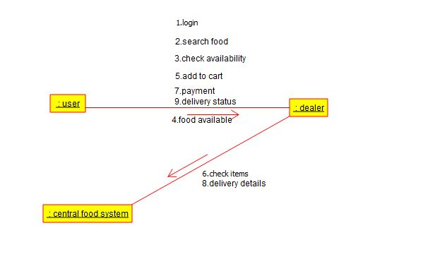

COMPONENT:

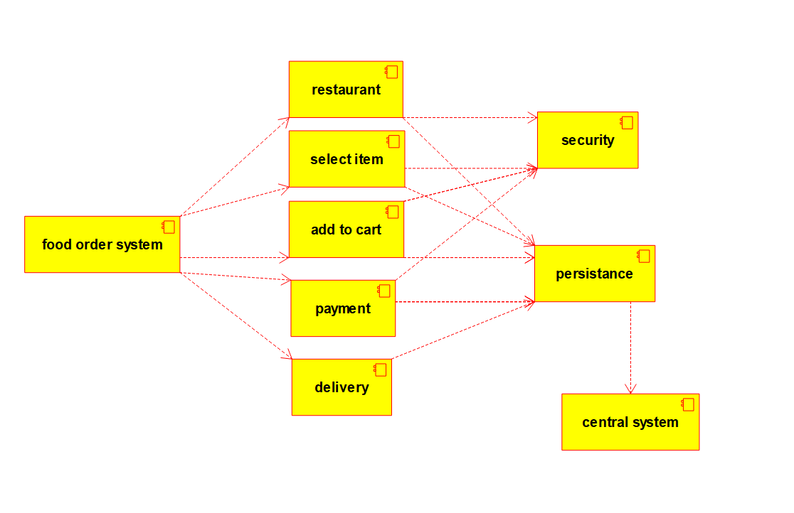

DEPLOYMENT:

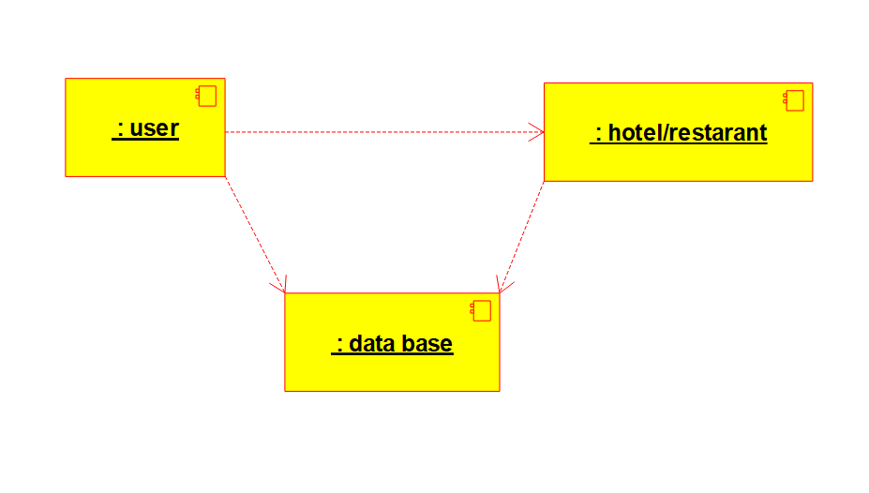

STATE:

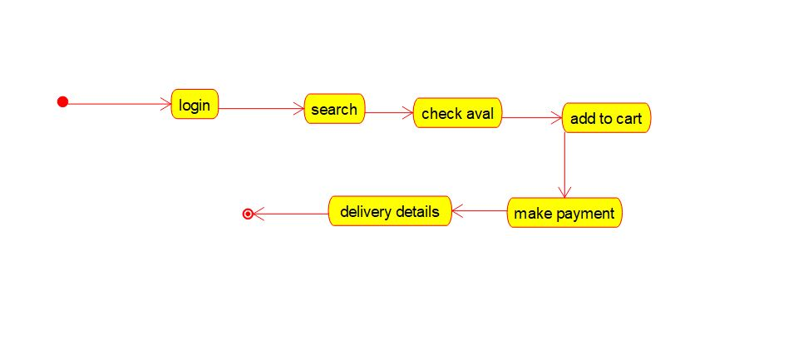

ER DIAGRAM:

